

National University

CSC 480 A

Computer Science Capstone

Professor Jeffery Appel, Ph.D.

Software Project Management Plan:

Immersive Robotics

December 14, 2015

Prepared By:

Michael Bradvica
Hardeep Kumar
Sanjay Parmar

Approvals:

Title | Name | Signature | Date
Client Representative | Dr. James Jaurez |  | 1/6/16
Class Leader | Dr. Jeffrey Appel |  | 1/6/16
Project Leader | Michael Bradvica |  | 1/6/16
Developer | Hardeep Kumar |  | 1/6/16
Quality Manager | Sanjay Parmar |  | 1/6/16

Revision History:

Revision No. | Date of Revision. | Document No. | Description | Name | Approval
1 | 12/14/15 | 1.0 | Initial | M. Bradvica | Yes
2 | 1/6/16 | 1.1 | 1st Revision | M. Bradvica | Yes

Table of Contents

1. Introduction
1.1 Project Overview
1.2 Project Deliverables
1.3 Evolution of the SPMP
1.4 Reference Materials
1.5 Definitions and Acronyms
2. Project Organization
2.1 Process Model
2.2 Organizational Structure
2.3 Organizational Boundaries and Interfaces
2.4 Project Responsibilities
3. Managerial Process
3.1 Management Objectives and Priorities
3.2 Assumptions, Dependencies, and Constraints
3.3 Risk Management
3.4 Monitoring and Controlling Mechanics
3.5 Staffing Plan
4. Technical Process
4.1 Methods, Tools, and Techniques
4.2 Software Documentation
4.3 Project Support Functions
5. Work Packages, Schedule, and Budget
5.1 Work Packages
5.2 Dependencies
5.3 Resource Requirements
5.4 Budget and Resource Allocation
  - Schedule

List of Figures
List of Tables

Additional Components
Index
Appendices

- Introduction

This Software Management Plan (SPMP) is a constantly updated document for the purpose and use of developing the Immersive Robotics Driver Station and accompanying Arduino library software. Both the Driver Station and Arduino library developed by the Immersive Robotics team is designed to address the needs for operability and lack of rules for Dr. James Jaurez’s High School Robotics group. This document will define the operations of the Driver Station and Arduino library. The document will also contain the deliverables and development plan for Team Immersive Robotics. Any changes to said plan will be noted and this document will be updated accordingly.

  - Project Overview
The project is design by Team Immersive Robotics to provide the National University High School Robotic group a Driver Station from which the user may choose from number of interfaces for control. The driver station will be an interactive, customizable experience that combines both elements of UX (user experience) and raw computer science. This will allow a driver to define their own experience. The core of the system will be a driver station where a number of input devices: Xbox 360 Controller, Joystick, and Driving Wheel, will be connected to a Windows based computer. The driver station will run on a windows device that parses the input from the devices and wirelessly transmits the commands over a Wi-Fi connection to an Arduino micro-controller. The micro-controller will then command the UTV to move accordingly. The driver station will allow for the user to customize their experience through a number of settings. These settings include the ability to customize the binding of input interfaces to their functions on the UTV. This means that a driver would be able to change the method of input for movement; instead of pushing forward on the joystick to go forward, the driver could bind forward movement to moving the joystick to the right. The second method of customization would be the selection of rules for control of cyber-physical factors; a cyber-physical factor could be anything from an arm lift to a hydraulically controlled device. Lastly, we want to re-imagine the driver station from a cloud perspective. This means that a web application would be located on a web server that could physically be located anywhere. A driver would be able to access the web application from any network equipped device. This would turn the interface of the driver station into a universal application that could accept input from an infinite number of devices.

  - Project Deliverable
The deliverables date for Immersion in Robotics is scheduled Feb 28, 2016 to Professor Juarez who currently teaches at National University High School Robotics Group. The Team KPJB will deliver the following documents to the client:
- Proposal Document
- Operational Concept Document (OCD)
- Software Project Management Plan (SPMP)
- Software Requirement Specification (SRS)
- Software Design Documentation (SDD)
- Software Testing manual (STM)
- Software User’s Manual (SUM)
- Working Driver Station and Arduino Library
- Platform to ensure testing of the application

Table 1.2: Project Deliverables and Associated Information

Deliverable | Item Detail | Date of Delivery | Quantity | Deliver To
Immersive Robotics
 | GUI | February 28, 2016 | 1 | Dr. James Juarez
 | RC Car with Wi-Fi Camera | February 28, 2016 | 1 | Dr. James Juarez
 | Visual Output | February 28, 2016 | 1 | Dr. James Juarez
Documentation
 | OCD | February 28, 2016 | 1 | Dr. James Juarez
 | SPMP | February 28, 2016 | 1 | Dr. James Juarez
 | SRS | February 28, 2016 | 1 | Dr. James Juarez
 | SDD | February 28, 2016 | 1 | Dr. James Juarez
 | STM | February 28, 2016 | 1 | Dr. James Juarez
 | SUM | February 28, 2016 | 1 | Dr. James Juarez

1.3 Evolution of the SPMP

The acting Software project manager of Immersive Robotics will submit any of the request of the
client to this current document. This document will be updated as the project progresses. Updates
should be expected in the following sections:

- References - updated as necessary

- Definitions, acronyms, and abbreviations - updated as necessary

- Organizational Structure will be updated as the team leaders are assigned for each phase.

- Technical Process - this section will be revised appropriately as the requirements and design decisions become clearer

- Schedule – as the project progresses, the schedule will be updated accordingly

1.4 Reference Materials

Pressman, R. (2010). Software engineering: A practitioner's approach (7th ed.). New York:

McGraw-Hill Higher Education.

  - Definitions and Acronyms

Table 1.3

Terminology | Definition
Arduino | A series of Italian based open source micro-controllers.
Servo | A motor that uses are series of gears to generate movement.
Windows | Operating System developed by Microsoft.
Web Application | Another name used to describe a web site.
3rd Party Library | A partially built application that allows for partial functionality for larger software projects.
Xbox 360 | A gaming console developed by Microsoft.
DirectX | A graphics and sound API developed by Microsoft to speed up the acceleration of graphics and sound on windows based computers.

1.4.2 Acronyms
Table 1.4
Terminology | Definition
UX | User Experience
UI | User Interface
WiFi | Wireless Local Area Network
RC | Remote Controlled
GUI | Graphic User Interface
UTV | Unmanned Terrain Vehicle
OCD | Operational Concept Document
QA | Quality Assurance
SPMP | Software Project Management Plan
SRS | Software Requirement Specification
SDD | Software Design Document
STM | Software Testing Manuel
SUM | Software User’s Manuel

2.0 Project Organization

2.1 Process Model

Team Immersive Robotics will the process model Waterfall to design the robotics interface, Driver Station, and Arduino library. The Waterfall Model is a sequential approach to software development that begins with a customer specification of requirement and progresses through planning, modeling, construction, and deployment. The final product culminating in ongoing support of completed software.
The process is as follows:
- Communication
- Planning
- Modeling
- Construction
- Deployment

During the communication phase, the team is scheduled to meet with the client and any representatives, the problem is discussed between the team and a possible list of solutions is proposed. During the planning phase, our problem scope is defined, and an abstract for our solution is formulated. The team will then decide upon which broad architecture will be used and the possible platforms. In the modeling phase, we will take our abstract and put into written form our platform for the solution, any architecture decisions that have been made, and our models for the final application. During construction, the application is built accordingly to the models that have been laid out. Finally, the application is tested and delivered to the client.
The Waterfall Model life cycle shown in figure below:
Figure 2.1.1: Waterfall Model
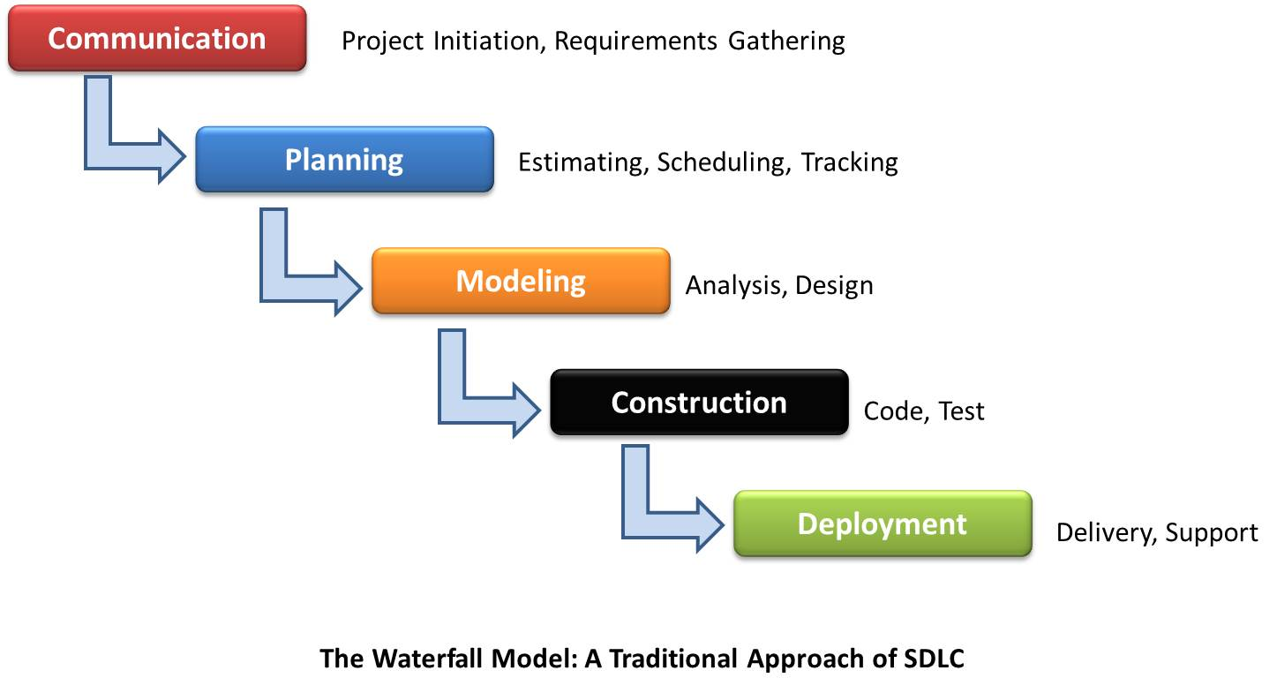
Source: http://en.wikipedia.org/wiki/Image:Waterfall_model.png

2.2 Organizational Structure

The Project Manager is responsible for the defining, planning, tracking, and overall management of the project. He is responsible for identifying key resources and providing the direction required for meeting the project objectives. He is additionally responsible for ensuring appropriate management, customer and supplier involvement throughout the life of the project. He must also be able to manage the schedule and task details, and any other details that pertain to the overall success of the project.
The Software Engineer will design the software application per client requirement. He will design, develop, and test the software solutions. The Software Engineer will report all updates to the Project Manager.
The Quality Manager role is responsible for guaranteeing a level of quality for the end client and end user. He will help to identify issues in development to both the Software Engineer and Project Manager. The Quality Manager will be responsible for testing the application to ensure that it meets the client’s requirements.

Figure 2.2.1 Overall Team Organization

Project Manager
Michael Bradvica
Software Engineer
Hardeep Kumar
Quality Manager
Parmar Sanjay

2.3 Organizational Boundaries and Interfaces

2.4 Project Responsibilities

For primary responsibilities per phase, please refer to section 2.4. Ultimately the entire project

team is responsible for the successful delivery of the product. Team member assignments per

deliverable according to their expertise:

Table 2.4.1 Role Specification
Role | Individual/Group | Description of Role
Project Leader | Michael Bradvica | Requirements Specification
Software Engineer/Developer | Hardeep Kumar | Analysis  Architecture Specification
Quality Manager | Sanjay Parmar | Component/Object Specification  Test Plan

3.0 Managerial Process

3.1 Management Objectives and Priorities
The main management objective is to deliver the project on-time with the highest possible quality. In order to insure a highest quality product, numerous checks and balances are embedded into the existing process.

3.2 Assumptions, Dependencies, and Constraints
The following elements have impact on the project:

3.2.1 Assumptions:
- The robotic unmanned terrain vehicle is readily available.
- The application should be able to interact with multiple input devices such as Xbox 360 Controller, Joysticks and driving wheels by connecting to a Windows based computer.
3.2.2 Dependencies:
- The project depends heavily on the feedback from NU Robotics Club and its lead Professor Juarez.
- The application has greater dependency on hardware such as UTV and different input devices.

3.2.3 Constraints:
- Due to the nature and availability of Wi-Fi connections, the device can have limited or no connectivity which can greatly impact the performance of the product.

3.3 Risk Management

3.3.1 Possible Risks of project:

Risk 1 – Team lacks skill needed to complete application.

Risk 2 – Application is under-developed and lacks features.

Risk 3 – Application is subject to feature creep and promises too many features, and it unable to properly support them.

Risk 4 – Inadvertent Error/Issue Unknown

Risk 5 – GUI/UI is too confusing to the user.

Risk 6 – A similar solution by another party is made readily available.

Risk 7 – The user’s computer many not support the application.

Risk 8 – A certain input device may not work correctly if replaced by similar model.

Risk 9 – Changes in application/library cause confusion.

Risk 10 – Base library for Arduino micro-controller changes.

Risk 11 – Delay in WiFi/controls causes latency of controls.

Risk 12 – Hardware malfunctions.
Table 3.3.2 Risk Prediction: Scales are 1 through 5.
Risk Issue: | Risk Description: | Probability of Risk: | Impact of Risk:
1 | Lack of Skills | 1 | 5
2 | Under-development | 3 | 4
3 | Feature creep | 3 | 5
4 | Issue Unknown | 2 | 3
5 | UI Confusing | 3 | 2
6 | Similar Solution | 1 | 1
7 | Inadequate Support | 1 | 5
8 | Input device malfunction | 3 | 4
9 | Changes cause confusion | 2 | 2
10 | Base library changes | 2 | 4
11 | Network Issues | 3 | 3
12 | Hardware malfunctions | 3 | 4

3.3.4 Risk Aversion Options

Risk 1 – Team lacks skill needed to complete application.

- Risk aversion options – Ensure that the team when formed had the proper skills necessary to finish the project. If there was a skill needed that was not present at the formation of the team, ensure that such skill will be learned during the process.
- Risk monitoring procedures – Constant communication with team to ensure that the project is moving at the pace necessary to finish on time.
- Risk mitigation – To keep in constant communication, the team has set up a Slack page that enables a person to propose a question, or post a topic at any time. This option is much better than email because Slack will keep a history of team communication.

Risk 2 – Application is under-developed and lacks features.

- Risk aversion options – Ensure that the client fully understands what will be delivered at the final date of delivery.
- Risk monitoring procedures – If the customer believes that a certain feature is not fully developed, or needs to be improved upon; then the team will work with the customer to ensure that his goals are met.
- Risk mitigation – Ensure that all of the features covered in the plan are fully implemented and working.

Risk 3 – Application is subject to feature creep and promises too many features, and it unable to properly support them.
- Risk aversion options – Team Immersive Robotics will focus on only delivering what is covered in the documentation. Any added complexity hastily added as a last minute feature will only increase the development of the project.
- Risk monitoring procedures – If at any point the team or the client feel that the project is becoming too cumbersome, the team and client will analyze the situation to make sure that only the most necessary features make it through production.
- Risk mitigation – Stick to the software plan and documentation. Do not allow for any added features to be added as last minute entities.

Risk 4 – Inadvertent Error/Issue Unknown

- Risk aversion options – The team will spend the appropriate amount of time to ensure that all major bugs have been found and fixed to ensure operation of application.
- Risk monitoring procedures – The team has a dedicated Quality Manager whose primary job is to guarantee that the application works properly and without interruption due to internal errors.
- Risk mitigation – When a bug or error is found, the proper measures will be taken to fix the error. The turnout for the correction of bugs is to be as small as possible to enable the client as much operation as possible.

Risk 5 – GUI/UI is too confusing to the user.

- Risk aversion options – The team in combination of the client, Quality Manager, and Software Engineer will test the GUI/UI with possible users to ensure that there is neither too much or too little information presented to the user.
- Risk monitoring procedures – The GUI will be built in components starting with a bare minimum. Additions will be made until it is deemed that any more components will only confuse the user.
- Risk mitigation – If the feedback from the users or client deems that the UI is too cluttered or not informative enough, the team will make the necessary changes to correct the issue.

Risk 6 – A similar solution by another party is made readily available.

- Risk aversion options – Ensure that our project is either better than the competitors project, or have some feature that cannot compare.
- Risk monitoring procedures – If the client is not satisfied or starts to seek another solution, ensure that all possible channels are exhausted to ensure that the project delivers what was promised.
- Risk mitigation – Ensure that the customer feels as if the project is going to plan at all points of execution.

Risk 7 – The user’s computer many not support the application.

- Risk aversion options – Check that the user’s computer is compliant ahead of time.
- Risk monitoring procedures – If the client or any user states that their computer may not support the application, work with them to solve the issue at hand.
- Risk mitigation – Check to see that the user’s computer has the latest version of the .Net framework installed for operation.

Risk 8 – A certain input device may not work correctly if replaced by similar model.

- Risk aversion options – The input devices initially used to build and test the application may not work if replaced by other similar entities.
- Risk monitoring procedures – While it cannot be guaranteed that every input device will work accordingly, ensure that a majority of DirectX input devices are able to function correctly.
- Risk mitigation – If a user or the client feels as if an input device is not working normally, work with them until the problem is corrected.

Risk 9 – Changes in application/library cause confusion.

- Risk aversion options – Make sure that any changes made after the initial release do not greatly change the major operations of the application.
- Risk monitoring procedures – If any changes are made past the initial release that either confuse or irritate the customer, work with them to ensure they are corrected.
- Risk mitigation – Ensure proper action during development to minimize any possible changes past the release date.

Risk 10 – Base library for Arduino micro-controller changes.

- Risk aversion options – There is the possibility that changes in the base Arduino core library hinder our own library, inhibiting operation.
- Risk monitoring procedures – If any Arduino updates “break” the application, release an update that corrects the changes.
- Risk mitigation – Keep up with any changes to the Arduino core library during the applications development.

Risk 11 – Delay in WiFi/controls causes latency of controls.

- Risk aversion options – The wireless/WiFi network is slow or inhibits the user proper tele operation of the UTV.
- Risk monitoring procedures – Ensure from an application perspective, the program runs as fast and as smoothly as possible.
- Risk mitigation – Ensure that the network used for operation is free from outside interference and the range of operation is not too large.

Risk 12 – Hardware malfunctions.

- Risk aversion options – Failure in hardware will make the application useless.
- Risk monitoring procedures – Make sure during development that any UTV to be used be the client is not overburdened by the same issues of feature creep as the application.
- Risk mitigation – If any hardware failures exist, work with the client and user to fix said problems.

3.4 Monitoring and Controlling Mechanics

3.4.1 Risk Monitoring Procedures

- To monitor the risk of the application, all systems and subsystems will be continuously monitored during development to reduce any risk possible.
- Risks will be assigned a priority level, with higher level risks being evaluated and assessed before lower risks, although this may vary in reality.
- Constant interaction with both the client and any possible users is the best course of action to reduce any risk present.

3.4.2 Contingency Plan

The following steps will be taken when a risk does occur:

- Any issues that arise will be noted by either the client or user and such will be alerted to the attention of the development team.
- The team will meet with the person who found the risk and an appropriate plan of action will be developed.
- Any issues found will be handled, and a new version of the application will be finalized and released.
- Any serious issues that require immediate attention will be handled on a case by case basis. A temporary fix may be made, or certain parts of the application may be disabled until a proper solution can be devised.

3.5 Staffing Plan

With the inclusion of the client, Dr. Jaurez, Ph.D, there are a total of four people working on the project: Michael Bradvica, Hardeep Kumar, and Sanjay Parmar. The required skills necessary include basic knowledge of the Arduino micro-controller and core library, knowledge of the .net framework and the C# language, and lastly, basic computer knowledge. Everyone involved in the project came from the National University Computer Science department. It is estimated that the project will continue past the deadline date of February 28, 2016 as the customer and Project Manager have previously discussed keeping the project open for future development.

4.0 Technical Process

Everyone in the Immersive Robotics team will be using the same set of development, documentation, and communication tools throughout development. Documentation will be done through the Microsoft Office Suite. Communication will be handled through a combination of traditional email, Google Hangouts, and Slack Team Communication platform.

4.1 Tools and Processes

All documentation used in the project will be built using the Microsoft Office Suite, specifically Microsoft Word and Excel. Storage of documentation and a revision history will be tracked via the Slack page. For application development, the Microsoft Visual Studio IDE and Arduino IDE will be required.

4.2 Software Documentation

The documentation of the application will be completed via the Operational Concept Document (OCD), Software Project Management Plan (SPMP), Software Requirement Specification (SRS), Software Design Document (SDD), Software Test Plan (STP), and Software Manual (SUM). All documentation will be completed via Microsoft Word.

4.2.1 Operational Concept Document

The OCD will provide the abstract for the Immersive Robotics projects and contains a general overview of the project.

4.2.2 Software Project Management Plan

The Software Project Management Plan is a document that tracks progress of the Immersive Robotics project. The document contains the general functional of the project and its general capabilities. The document also covert the composition of the team, the list of components that the project will comprise of, and the risk associated with the project.

4.2.3 Software Requirements Specification

The SRS contains the details about the product, the functions of the product, its constraints, and the characteristics that will be contained in the project.

4.2.4 Software Design Document

The SDS is an overview of the Driver Station and Arduino Library. The document will be concerned with the architecture of the application.

4.2.5 Software Test Plan

The STP will contains information regarding the testing process of the project. It will detail the composition of the test cases, the requirements of the test cases, and the person responsible for conducing the tests.

4.2.5 Software Manual

The Software Manual will provide the information required for both the client and end-user on how to operate the application as well any the requirements needed to run the application.

4.3 Project Support Functions

4.3.1 Configuration and Version Support

To ensure that the application does not run into issues concerning different versions due to more than one developer, a version control will be used. GitHub will maintain a master version of the application. When a developer wishes to make a change, he will make a pull request from the master branch, any changes done will be submitted to approval. The Project Manager will then note any changes made to the application and either approve or disapprove the changes. GitHub will keep a history application so that a rollback will be possible if needed. This will ensure that each member is working on the appropriate version.

4.3.2 Quality Assurance

Quality Assurance of the application will be enforced via code reviews of any changes by the project manager and client. Proper maintenance of the application will be enforced via the source control, GitHub.

5.0 Work Packages, Schedule, Budget

The general work package is composed of three main components: the documentation of the application, the actual development of the application, and the testing of the application.

Figure 5.1 General Structure

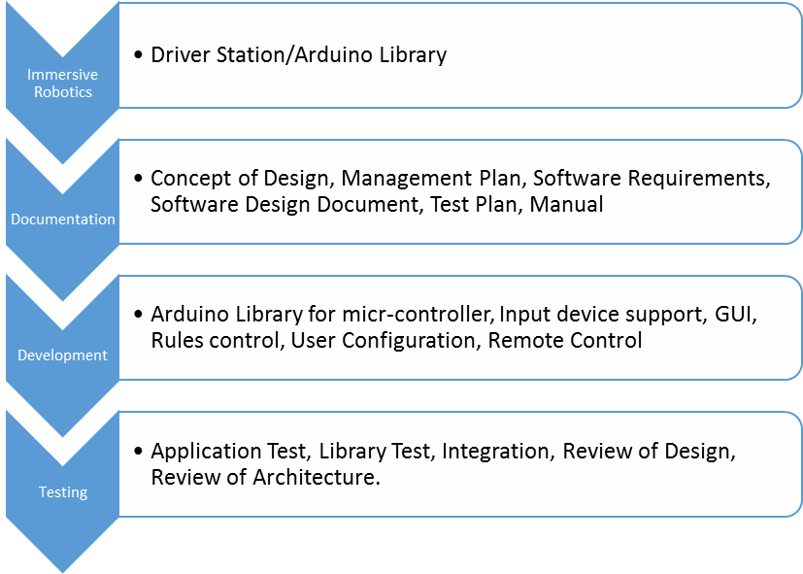

5.2 Dependencies

The following dependencies exist with the packages:

Figure 5.2.1 Project Dependencies

Working Application

Completed Test Plan
Testing Documentation
Completed Arduino Library
Completed Driver Station

Software Design Document
Software Requirements Specification
Software Project Management Plan
Operational Concept Document
Approved Concept

5.3 Resource Requirements

The following concerns the necessary resources for the completion of the project:

Each member of the team will needed a Windows based computer with the latest version of the .NET framework and Arduino IDE for development. A copy of the Windows Office Suite, or similar application that can work with Office file formats for documentation. And finally, and internet connection is required for communication through email, Slack, Google Hangouts, and version support via GitHub. These requirements are to be met by each member accordingly. Development will be done at the discretion of each team member as there is no defined central meeting or development area. The client is located at the National University Kearny Mesa location in San Diego. All interaction and testing of the hardware and application will be done at the Kearny Mesa location. Michael Bradvica, as project manager will be doing most of the travel required to talk to the client at said location.

5.3.1 Developers

The project does not requirement a certain amount of people to complete. However, the rules that should naturally exist would be for a single developer to handle the Arduino library, one to design the User Interface, one to develop the back-end of the driver station, and one to develop the web application.

5.3.2 Resource Allocation

Operation | Number of Persons Involved | Personnel
Original Concept | 4 | All
Operational Concept | 4 | All
Software Project Management Plan | 4 | All
Software Requirements | 2 | Project Manager/Engineer
Architecture | 2 | Project Manager
Test Plan | 2 | Project Manager/Quality Manager
Manual | 2 | Project Manager/Quality Manager

5.3.3 Tools Allocation

Support Software | Hardware | Facility | Travel
Concept | None | Client Home | Yes
Documentation | Any | Any | None
Modeling | Any/Visual Paradigm | Any | None
Application IDE | Windows PC | Any | None
Arduino IDE | Windows PC | Any | None
Application Testing | Windows PC | Any | None
Unit Testing | Windows PC | Client Home | Yes

5.4 Budget

No budget will be required as the client will be providing any necessary financial support. Any costs needed for the application will be covered by the National University Robotics Team. Any earned value for the application will be determined by the client. However, the client has intended for the final application to be distributed free of charge to anyone who would like to use it. Distribution of the source code has not been discussed as of this point in time.

5.5 Schedule for deployment

Project Goal | Time of Delivery
Concept of Idea and Confirmation | Late November
OCD | Early December
SPMP | Late December
SRS | Early January
SDD | Late January
Class Diagram | Early February
User Diagram | Early February
User Interface | Early February
Website Diagram | Early February
Working driver station | Mid February
Working Arduino library | Mid February
Testing documentation | Mid February
Completed testing | Late February
Working product | Late February
Completed project | Late February

5.6 System Transition Plans

Because this is a customized solution that does not replace any existing software, the transition will be the time required to learn and utilize the application. An installation wizard will be included with the project that will allow for easy installation onto any computer. When the application is launched, a configuration wizard will allow for any user to define their own rules for operation. Lastly, the Arduino library will require the user to manually map the available motors to the library controls. The total time needed to transition to the application should not exceed more than fifteen minutes.

